Dog Postures
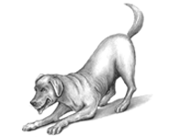Playful or Play Bow Posture
The play bow invites others to play. Dogs may also use a play bow to communicate that
any prior rough behavior was not intended to be threatening. Dogs may also assume this
posture if they have done something wrong, to let you know they meant no harm and really
just wanted to play.
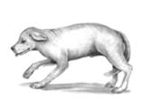Active Submission Posture
A dog displaying active submission behavior is offering signs of submission to a superior
dog or person to avoid any additional threats or confrontations. This dog is a bit fearful and
hopes the superior individual will either retreat or show signs of friendliness.
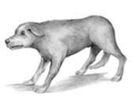Defensive Threat Posture
Be very concerned about dogs in defensive threat posture. These dogs are showing
signs of fear or submission and aggression. Dogs displaying this behavior are afraid
and may attack if pushed. This is the posture assumed by fear biters, dogs who bite
out of fear. People often read them wrong, thinking they are harmless because of their
facial expression show signs of submission. They do not look beyond the facial
expression to the rest of the dog's posture to see what he is really communication.
Defensive threat is the most dangerous body posture of dogs.
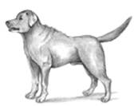Aggressive-Dominant or Offensive Threat Posture
This is a very threatening posture communicating confidence and dominance if confronted.
Dogs in this posture are preparing to attack and, if pressed, will bite and will fight.
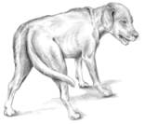Stressed
Signs of stresses in dogs are as following:
Shaking or shivering scratching excessive dandruff(exfoliate) excessive shedding dilated
pupils excessive blinking loss of appetite diarrhea restlessness use of calming signals
sweating through pads of feet frequent or inappropriate urination panting, salivating biting
or licking self hiding or trying to leave
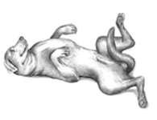Passive Submissive
A completely submissive dog is very afraid of a confrontation. He is signaling to the
dominant individual absolute surrender assuring that he is of no threat. Some dogs
may show complete submission, expect their inguinal (groin) region, as a friendly
gesture differing to their owners or their animal friends.

